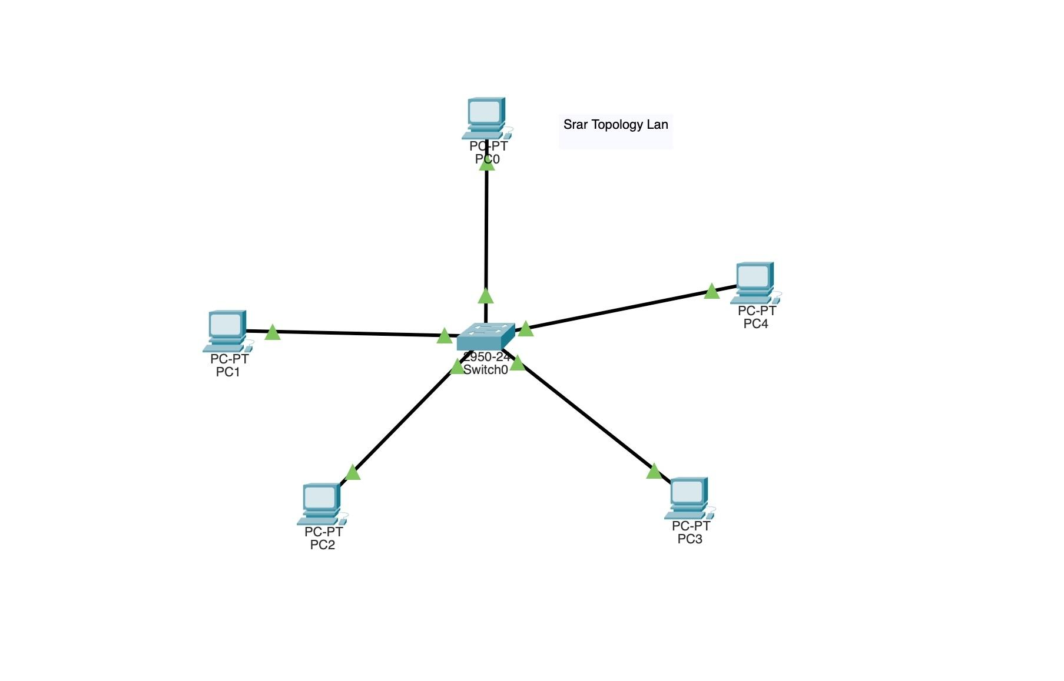

**Notes**

* Place 5 pcs
* Set PC IP Adresses
* Added a Switch
* Connected with copper straight-throughwire
* Green arrows means succusfull connection.